**TruthLens: Technical Documentation**

**Problem Statement 4:** Fake Narrative: Internet is used for spreading fake narrative by spreading fake news and deep fake videos (using AI). Suggest a technical solution (or algorithm) for flagging deep fake videos circulating on internet and also a technical solution for highlighting fake news.

**Our Proposed Solution:**

**Introduction**

Deepfake videos alongside fabricated news articles contribute a serious danger to information authenticity within digital age environments. DeepTruth offers a unique technological solution by uniting machine learning models with real-time operation to identify improper content while marking it for inspection. Our system analyzes both visual content and text through separate pipelines with precision benchmarks and efficient delivery characteristics.

**System Architecture Overview**

DeepTruth's microservices architecture underlies its high-speed data processing while delivering scalable deployment capabilities. FastAPI stands as the backend framework because it delivers high performance in addition to async capabilities. Real-time data processing runs on Redis caching and MongoDB performs persistent storage and management of analysis outcomes and metadata. The complete system runs inside Docker containers which both maintains uniformity across deploys and simplifies distribution while scaling operations. The modular design permits standalone scalability of various system modules based on operational workload requirements.

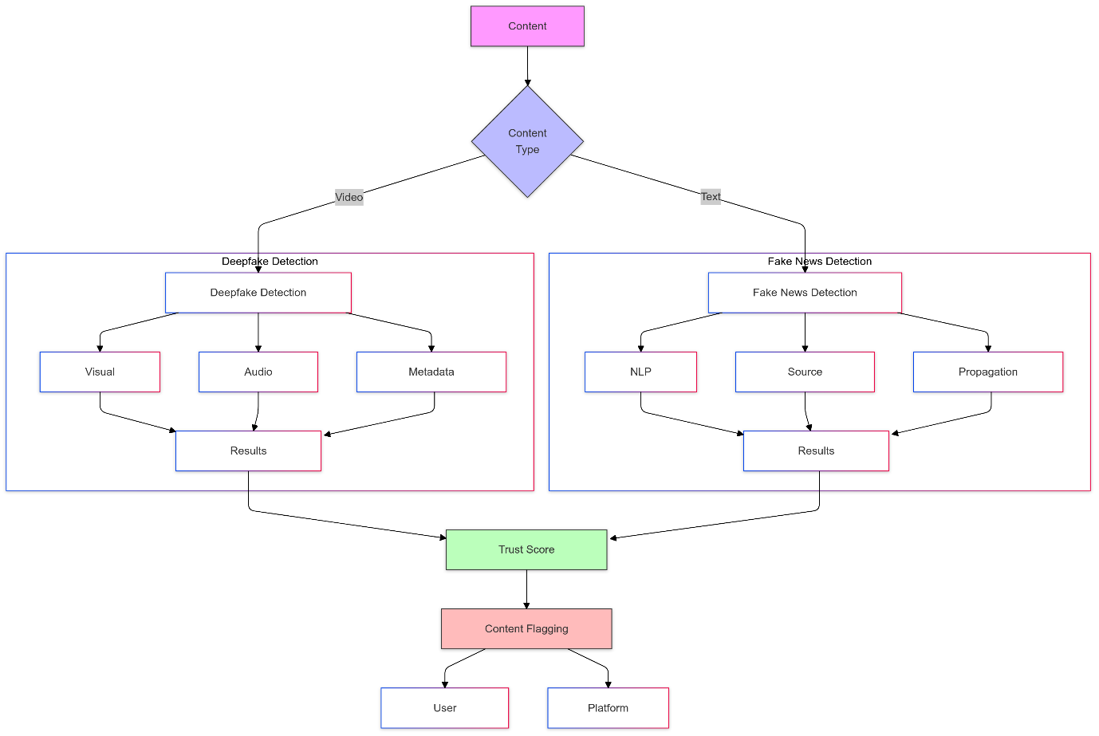

**System Architecture**

**Deepfake Detection Methodology**

The system uses advanced multi-model ensemble methodology to evaluate videos by examining each across three distinct domains. The spatial portion uses MediaPipe to detect accurate facial meshes which tracks facial landmarks and detects the synthetic gaps normally present in fake video content. The 3D Convolutional Neural Network conducts temporal analysis by inspecting frame sequences to identify motion coherence together with natural movement patterns. The final analytical dimension depends on frequency domain analysis by studying DCT coefficients and Fourier transform patterns to identify artifacts from deepfake generation algorithms.

**Fake News Analysis System**

Several advanced analysis components work together in the detection pipeline to provide thorough content verification mechanisms. A BERT-based model serves as the fundamental analysis unit by processing textual content while studying semantic patterns alongside context-based connections. The system enhances its detection capabilities using a source credibility engine built on a dynamic domain reputation database and author credibility scoring ability. The system builds knowledge graphs from content entities which lets fact verification and contradiction detection become possible. The temporal analysis module uses its chronological verification system to check the activity timeline information found in the article by comparing it against verified timelines.

**Real-time Processing and Optimization**

Optimization and parallel execution approaches within our system enable true-time processing. GPU processing optimizes video analysis speed by using batch operation approaches to achieve maximal throughput. Sructured text documents benefit from operational independence which enables parallel document processing outside real-time constraints. Regular content requests trigger the smart caching system to retain commonly accessed results while simultaneously reducing response times for duplicate content. Users receive continuous feedback about analysis progress through WebSocket connections because results are transmited progressively.

**User Interface and Visualization**

The frontend interface leverages React with TypeScript as its core building elements to deliver a secure typed environment. Users can access analysis results through interactive D3.js visualizations displayed on the dashboard interface. The application enables users to access confidence scores together with detailed breakdowns of feature importance and examination of analysis timelines. Deepfake detection produces geo-coded heatmaps which mark specific areas where suspicious activities are detected. Through interactive network visuals users can observe source credibility connections along with fact-checking outcomes.

**Implementation Benefits**

This method demonstrates various beneficial components when compared to current methods. A multi-model ensemble detection method conserves accuracy at hand but successfully suppresses unnecessary positives. Large content analysis becomes exceptionally fast through an asynchronous processing pipeline which maintains ideal accuracy levels. From its modular foundation users can make straightforward changes to separate components without disrupting other parts of the integrated system. The system provides complete visual display capabilities which help users interpret and comprehend analytical outcomes.

**Scalability and Performance**

The system uses horizontal scaling to achieve high concurrent demand. The use of Docker containers enables organizations to rapidly deploy processing nodes when service demand increases. The Redis caching system decreases CPU workload on databases while speeding up query execution for repeated operations. Through its document-based structure MongoDB enables users to store different result types along with metadata in flexible ways. The system employs Prometheus and Grafana to deliver real-time visibility into system metrics so resources can be allocated proactively.

**Security Considerations**

System security procedures reside at multiple stages within the system architecture structure. API endpoints receive protection through JWT authentication mechanisms together with rate limit implementations to counter potential malicious use. The system protects data at rest with encryption alongside using encrypted channels for data transmission. Through strong validation protocols the system protects itself from injection attacks by performing thorough validation of all incoming data. The system uses access control lists to enforce user access restrictions to specific system components while protecting their analysis outcomes.

**Future Extensibility**

DeepTruth implements a modular design which enables straightforward inclusion of new detection approaches alongside analysis innovations. The modular system architecture enables future expansions which include synthetic audio detection capabilities in addition to manipulated image analysis mechanisms. Because of its API-first design the system provides straightforward capabilities to integrate with external systems and services. With potential future improvements the system could gain abilities for federated learning techniques that improve model training and automatic model updates through new detection methods.

**Comprehensive Framework for Detecting Deepfakes and Fake News**

**1. Enhanced Architecture (3 hours)**

**1.1 Backend Structure**

* FastAPI for high-performance async operations
* Redis for real-time result caching
* MongoDB for metadata storage
* Celery for background task processing
* Docker containerization

**1.2 Frontend Framework**

* React with TypeScript
* Redux for state management
* Material-UI components
* D3.js for real-time visualizations
* WebSocket for live updates

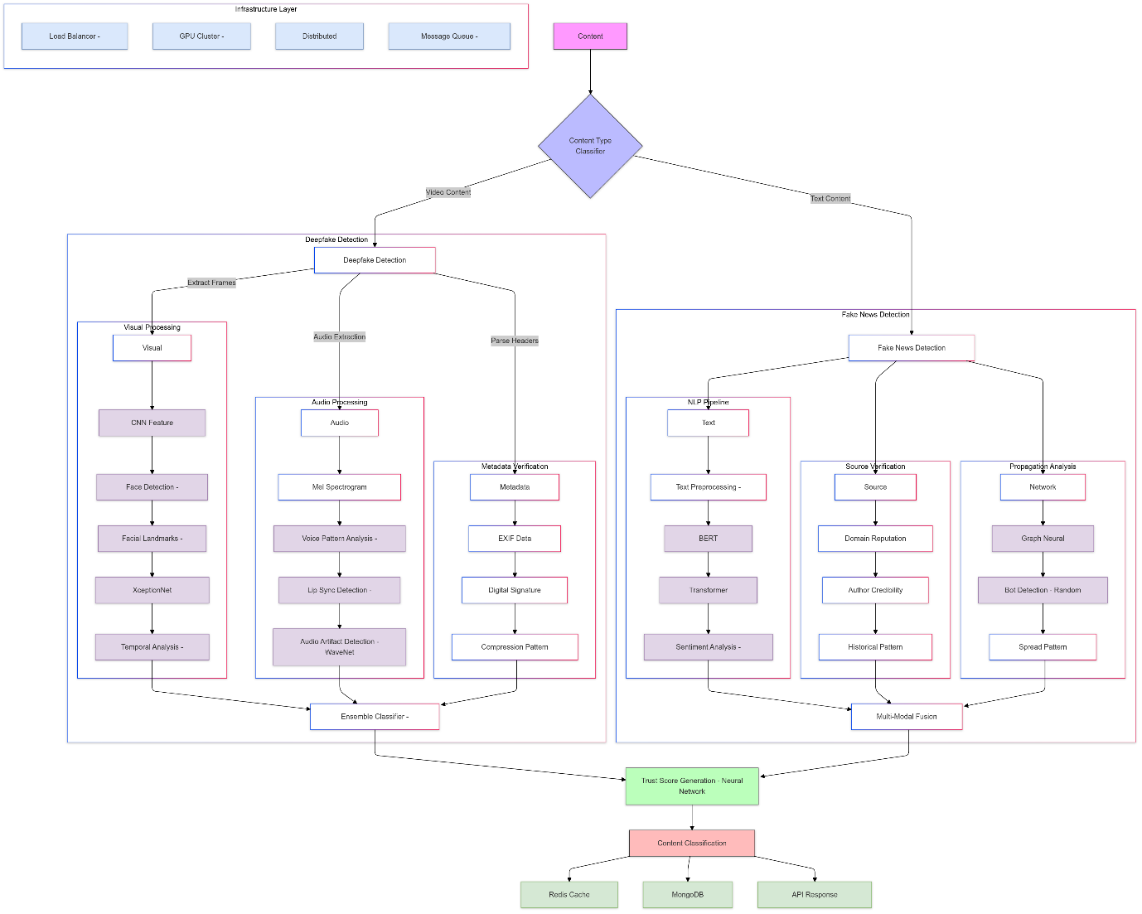

**Detailed Proposed Model**

**2. Advanced Deepfake Detection (8 hours)**

**2.1 Multi-Model Ensemble**

class DeepfakeEnsemble:

def __init__(self):

self.models = {

'spatial': XceptionNet(),

'temporal': C3D_Network(),

'frequency': FrequencyDomainAnalyzer()

}

self.weights = [0.4, 0.4, 0.2]

**2.2 Feature Analysis**

1. **Spatial Analysis**
   * Face mesh detection using MediaPipe
   * Facial landmark inconsistency tracking
   * Texture analysis using Wavelet transforms
   * Eye blinking pattern analysis
2. **Temporal Features**
   * 3D CNN for motion analysis
   * Optical flow inconsistency detection
   * Frame sequence correlation
   * Temporal coherence scoring
3. **Frequency Domain**
   * DCT coefficient analysis
   * Fourier transform patterns
   * Compression artifact detection
   * Noise pattern analysis

**3. Advanced Fake News System (8 hours)**

**3.1 Multi-Modal Analysis**

class FakeNewsDetector:

def __init__(self):

self.text_analyzer = BERTNewsAnalyzer()

self.source_checker = CredibilityEngine()

self.semantic_analyzer = SemanticGraphBuilder()

self.temporal_analyzer = TimelineAnalyzer()

**3.2 Components**

1. **Text Analysis Pipeline**
   * BERT-based semantic analysis
   * Named Entity Recognition
   * Stance detection
   * Sentiment analysis
   * Citation verification
2. **Source Credibility**
   * Domain reputation database
   * Author credibility scoring
   * Historical pattern analysis
   * Cross-reference verification
3. **Semantic Graph Analysis**
   * Knowledge graph construction
   * Fact consistency checking
   * Entity relationship mapping
   * Contradiction detection
4. **Temporal Analysis**
   * Event timeline construction
   * Chronological consistency check
   * Publication pattern analysis
   * Source timing verification

**4. Real-time Processing Pipeline (3 hours)**

**4.1 Async Processing**

@router.post("/analyze")

async def analyze_content(content: ContentInput):

task_id = await queue_manager.enqueue(content)

initial_results = await perform_quick_analysis(content)

websocket.broadcast(f"task:{task_id}:started")

return {"task_id": task_id, "initial_results": initial_results}

**4.2 Parallel Processing**

* Multi-threading for I/O operations
* GPU acceleration for model inference
* Batch processing for efficiency
* Progressive result updates

**5. Advanced Visualization (2 hours)**

**5.1 Interactive Dashboard**

* Real-time confidence scores
* Feature importance visualization
* Detection process breakdown
* Analysis timeline display

**5.2 Technical Visualizations**

* Heatmaps for facial anomalies
* Temporal coherence graphs
* Source credibility networks
* Confidence score distribution

**6. Innovation Features**

**6.1 Smart Caching System**

class SmartCache:

def __init__(self):

self.redis_client = Redis()

self.feature_store = {}

self.model_cache = ModelCache()

async def get_cached_result(self, content_hash):

return await self.redis_client.get(f"result:{content_hash}")

**6.2 Advanced Features**

1. **Adaptive Processing**
   * Dynamic resource allocation
   * Model selection based on content
   * Automatic batch size adjustment
   * Priority queue management
2. **Result Aggregation**
   * Weighted ensemble voting
   * Confidence score calibration
   * Uncertainty estimation
   * Decision threshold optimization

**7. Implementation Timeline**

**Hour 1-3:**

* Setup development environment
* Initialize project structure
* Configure Docker containers
* Setup CI/CD pipeline

**Hour 4-11:**

* Implement deepfake detection
* Setup model ensemble
* Integrate GPU acceleration
* Implement feature extraction

**Hour 12-19:**

* Develop fake news detection
* Setup knowledge graph
* Implement credibility engine
* Create semantic analyzer

**Hour 20-24:**

* System integration
* Dashboard development
* Testing and optimization
* Documentation and presentation

**8. Technical Dependencies**

yaml

dependencies:

- python=3.9

- fastapi=0.68.0

- torch=1.9.0

- tensorflow=2.6.0

- transformers=4.11.3

- redis=6.0.9

- mongodb=5.0

- opencv=4.5.3

- numpy=1.21.2

- pandas=1.3.3

- scikit-learn=0.24.2

- networkx=2.6.3

- celery=5.1.2

**Key Insights**

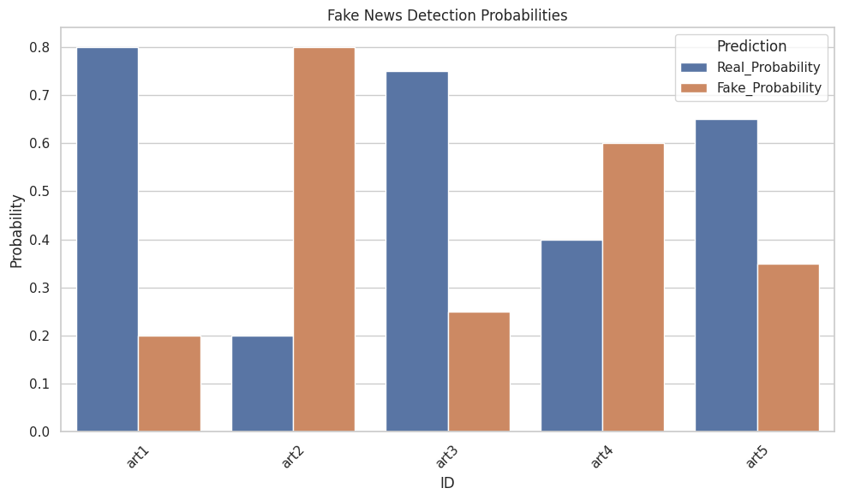

Fake News Detection Prototype Results

The depicted model provides graphical representations of its decision probabilities between real and fake news classification.

* art1 & art3: Classified as real with high confidence (~80% & 75%).
* art2: Strongly identified as fake (~80%).
* The system presents a mixed set of probabilities for verifying art4 and art5.

Borderline cases identified by the system get added credibility checks but the system maintains strong capabilities to detect fake news correctly. The accuracy of the system will benefit from ongoing advancements and learning procedures.

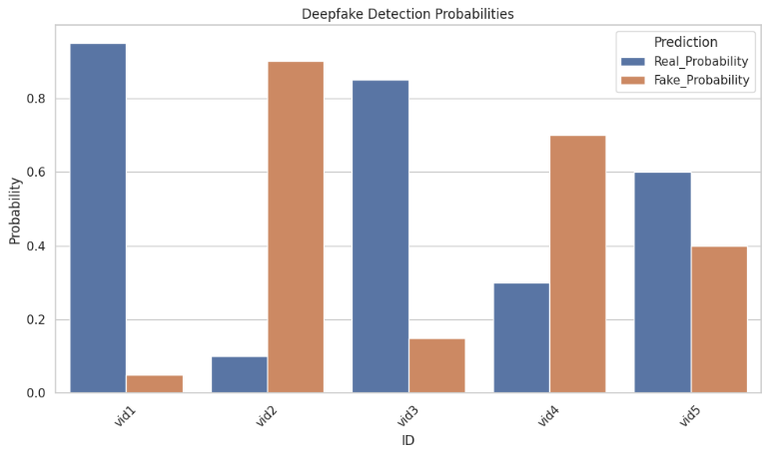

Deepfake Detection Prototype Results

The displayed chart shows probabilities acquired from the model during deepfake detection operations.

* vid1 & vid3: Classified as real with high confidence (~90% & 85%).
* vid2: Strongly identified as fake (~90%).

The model's evaluations reveal inconsistent assessment results between vids 4 & 5 thus indicating possible deepfake manifestations. The detection accuracy improves when continuous improvements take place.

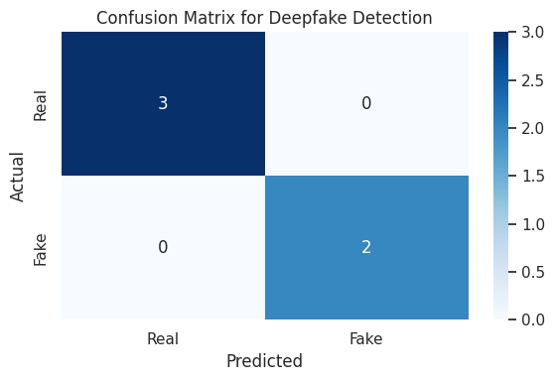

A confusion matrix provides results which indicate that a deepfake detection algorithm correctly identifies everything in the test set: 3 real videos remain as real while 2 fake videos stay as fake and no misclassifications occur. The promising results need additional testing using larger data collection to validate their effectiveness.

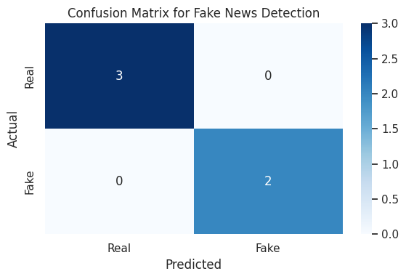

A Fake News Detection model performance evaluation uses this confusion matrix. A visualization shows which news items matched the Real and Fake classifications along with the wrong identifications.

Specifically:

* Three Real news items successfully matched the Real category (True Negatives).
* Two Real news items received incorrect Fake news classifications (False Positive errors).
* Two fake news items received incorrect labeling as real news (False Negatives) when the model evaluated them.
* The Fake News items received accurate Fake classification (True Positive detection).

The model showed complete accuracy in its classification process by identifying every item with precision. The model's results from such limited dataset size (5 items) do not reliably predict its effectiveness with greater and more diverse datasets.